Programming Fundamentals Lab
Lab 01 Assignment - Getting Started with C++
Pseudocode and Flowcharts (Tasks 5, 6 and 7)
Name: Aaliyan Amjad
Roll Number: 2603005
Section: BSCSev B
Repo: https://github.com/aaliyann-exe/programming-fundamentals-lab

Task 1 - Cafeteria Bill
Output
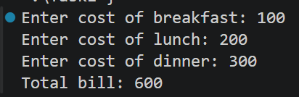

Task 2 - Escape Sequences
Output
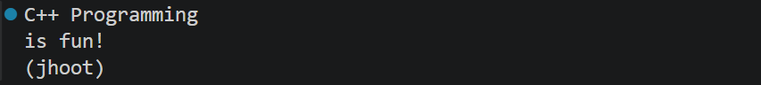

Task 3 - Table using \t
Output
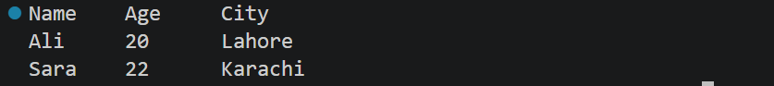

Task 4 - Swap using a third variable
Output
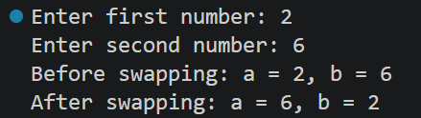

Task 5 - Total Marks and Percentage
Pseudocode
START
INPUT marks1, marks2, marks3
total = marks1 + marks2 + marks3
percentage = (total / 300.0) * 100
PRINT total
PRINT percentage
END

Flowchart
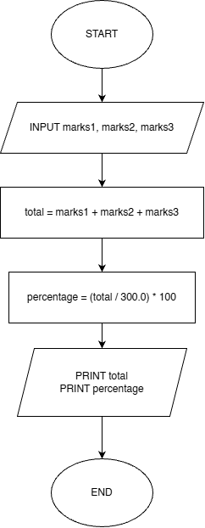
Output
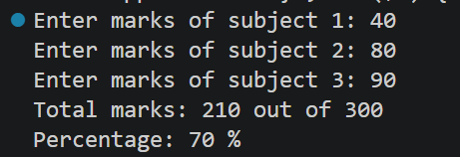

Task 6 - Area and Circumference of a Circle
Pseudocode
START
SET PI = 3.14159 (constant)
INPUT radius
area = PI * radius * radius
circumference = 2 * PI * radius
PRINT area
PRINT circumference
END
Flowchart
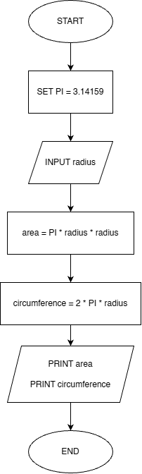
Output
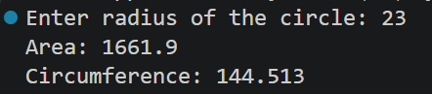

Task 7 - Cab Fare Estimator
Pseudocode
START
SET baseFare = 80
SET ratePerKm = 22
SET SURCHARGE = 50 (constant)
INPUT distance
totalFare = baseFare + (ratePerKm * distance) + SURCHARGE
PRINT totalFare
END

Flowchart
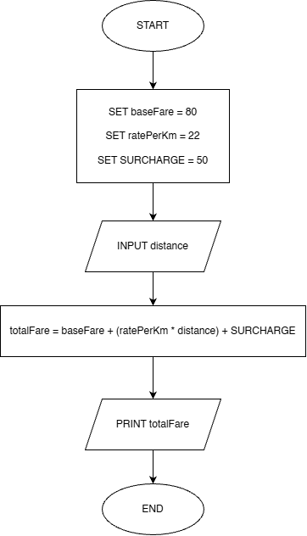
Output
